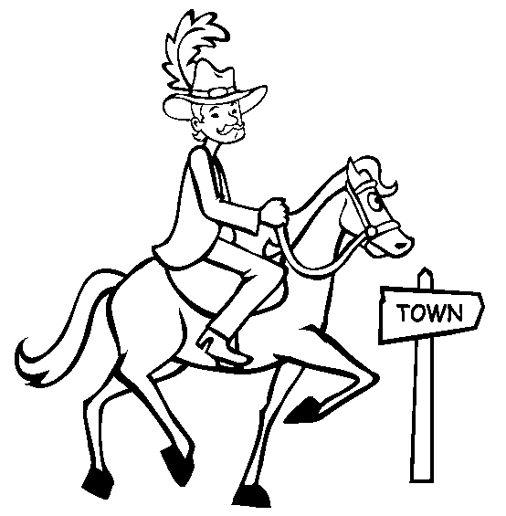

Yankee Doodle

Yankee Doodle came to town,
riding on a pony,
he stuck a feather in his cap
and called it Macaroni.

Yankee Doodle

Yankee Doodle came to town,
riding on a pony,
he stuck a feather in his cap
and called it Macaroni.

Georgie Porgie
Georgie Porgie pudding and pie,
kissed the girls and made them cry
when the boys came out to play,
Georgie Porgie ran away.

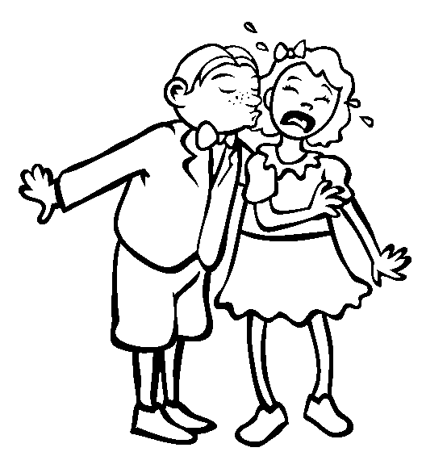

Georgie Porgie
Georgie Porgie pudding and pie,
kissed the girls and made them cry
when the boys came out to play,
Georgie Porgie ran away.

